Class activity CO3
Name:M.Nandhini
Reg.no:192472318

1. Multiple Catch Statements
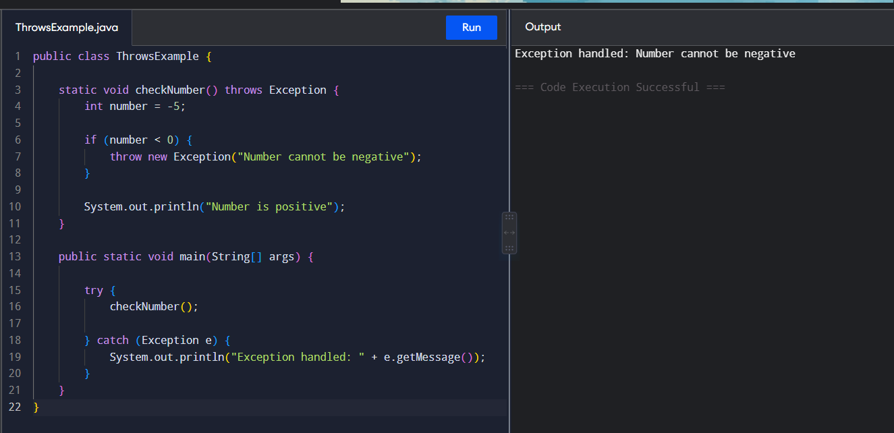
2. StringIndexOutOfBoundsException
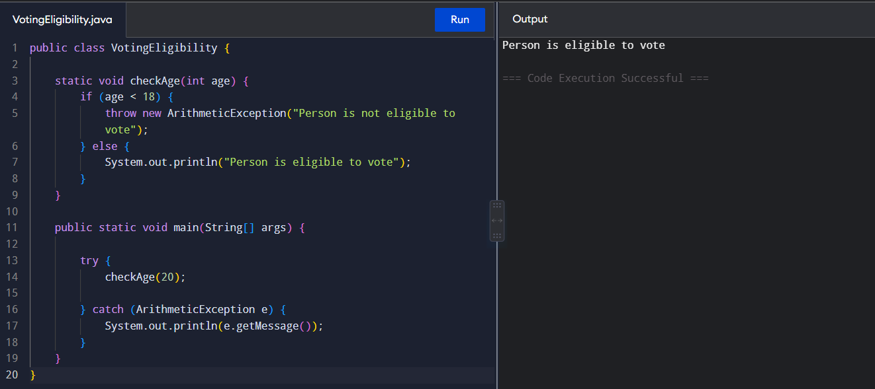
3. finally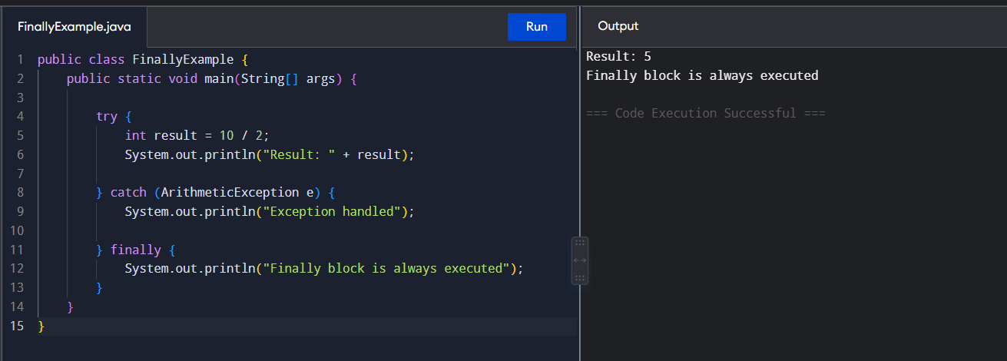

4. throw — Check Person Eligible to Vote
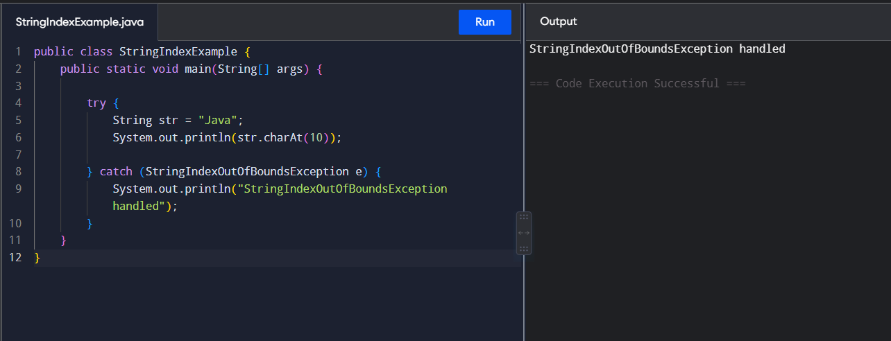
5. throws
